**Database Files (DAO)**

* Assignment
* Course
* Enrollment
* Grade
* GradeCategory
* User

See xls files for file relationships.

activity_home_page

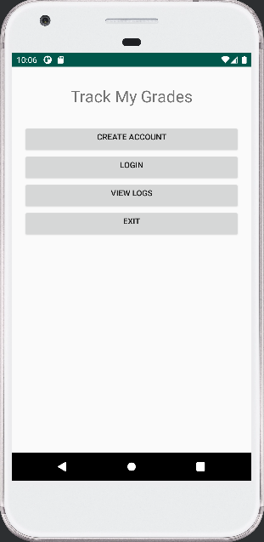

activity_createacount

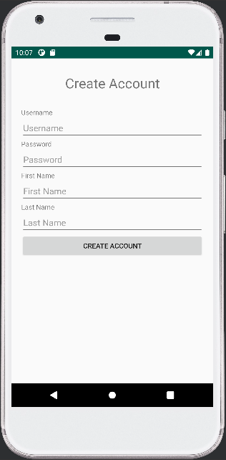 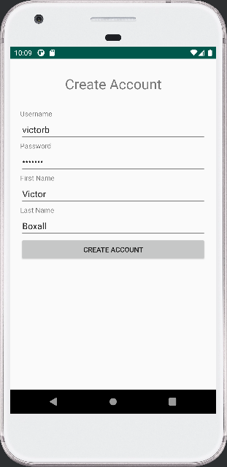

Victor Boxall

victorb

victorb

activity_view_log

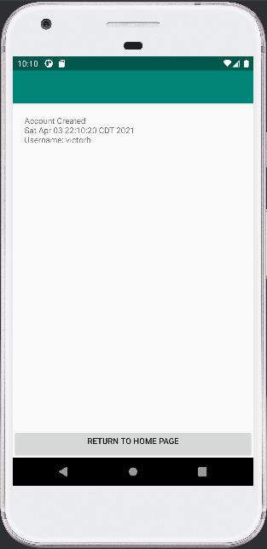

activity_login

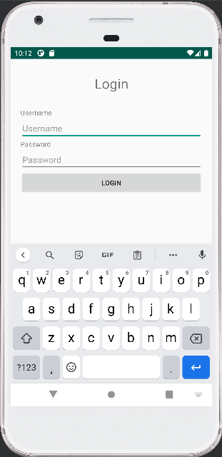 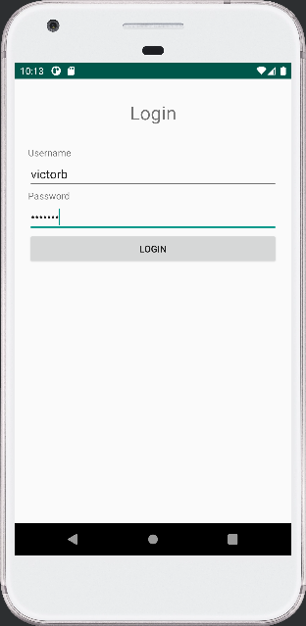

victorb

victorb

activity_menu

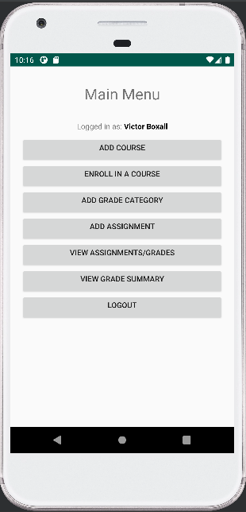

activity_add_course

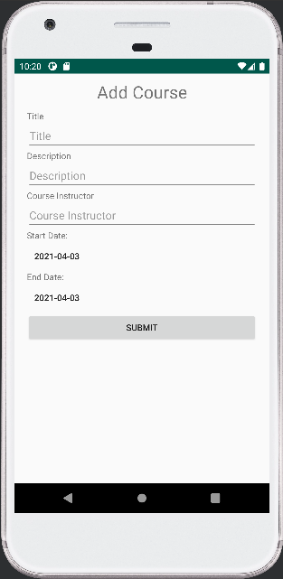 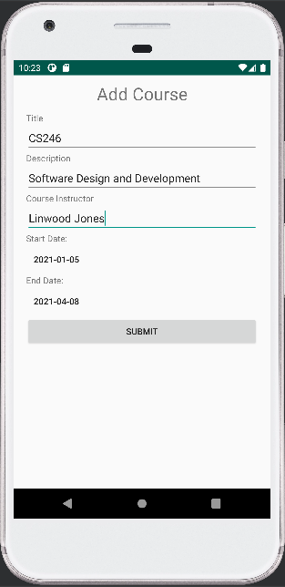

activity_add_grade_category

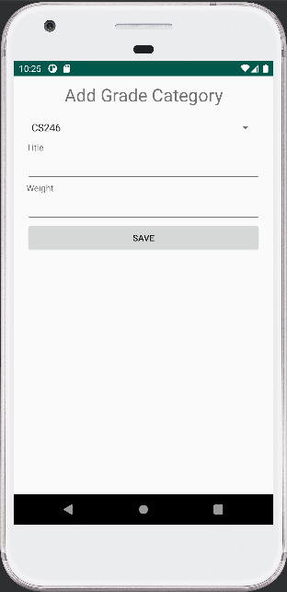 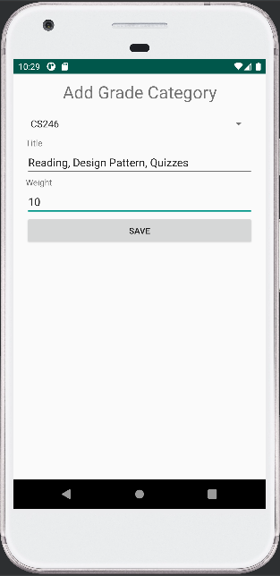

|  |  |
| --- | --- |
| **Item** | **Weight** |
| Reading (Weeks 1-6) & Design Pattern (Weeks 7-13) Quizzes | 10% |
| Team Activities (Weeks 1-6) | 10% |
| Individual Assignments (Weeks 1-6) | 40% |
| Team Project | 40% |

activity_enroll_course

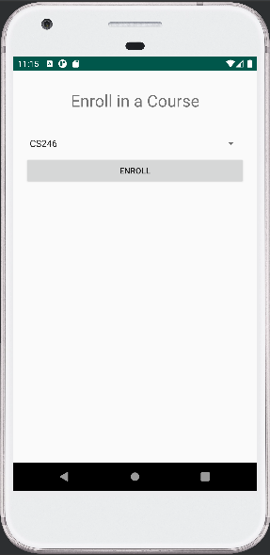

activity_add_assignment

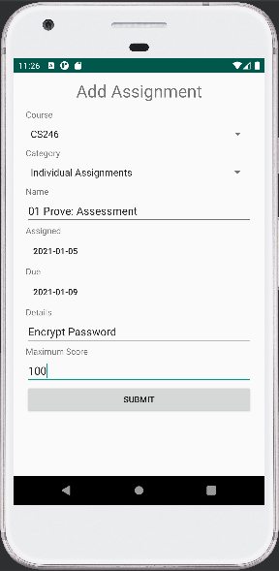

activity_view_grade_list

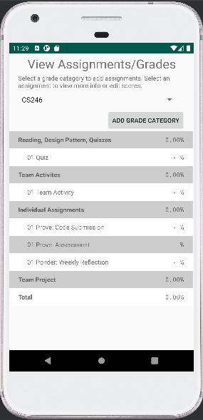

activity_view_grade_summary

